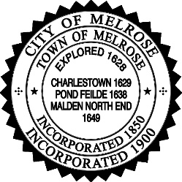
CITY OF MELROSE
OFFICE OF THE CITY CLERK
Kristin Foote, City Clerk

ANNUAL DOG LICENSE REGISTRATION
Per MGL c. 140 §137

Register or renew online: www.cityofmelrose.org/dogs

To license your dog(s) by mail, please submit the following:
- A copy of a valid rabies certificate
- Appropriate fee (per dog) payable by check to the City of Melrose

- Spayed/Neutered $20.00
- Intact $23.00

- Completed form below

Mail to: Melrose City Hall, City Clerk’s Office, 562 Main Street, Melrose, MA 02176
Owner Name:
Address:
(Include Apt. #)
Phone Number:
Email Address:
 | Dog #1 | Dog #2 | Dog #3
Name:
Date of Birth:
Gender:
Breed:
Color:
Rabies Expiration
Date:
Neutered/Spayed: | YES NO | YES NO | YES NO

If you no longer own a previously licensed dog, please notify us at clerks@cityofmelrose.org. If you have questions, please contact the Melrose City Clerk’s Office at 781-979-4113.

