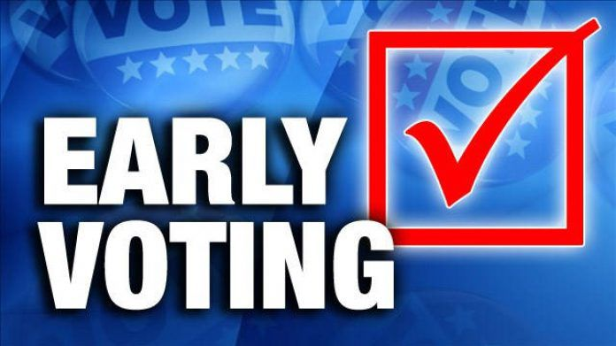
In-person Early Voting for the Presidential Primary Election will be available to all Melrose voters at City Hall.

Early Voting Schedule:

Saturday February 24th 11:00 am – 5:00 pm
Monday February 26th 8:30 am – 4:00 pm
Tuesday February 27th 8:30 am – 4:00 pm
Wednesday February 28th 8:30 am – 4:00 pm
Thursday February 29th 8:30 am – 4:00 pm
Friday March 1st 8:30 am – 12:30 pm

Make sure you are registered to vote:
The last day to register to vote in this election is Saturday, Feb. 24. Register online or in person.

